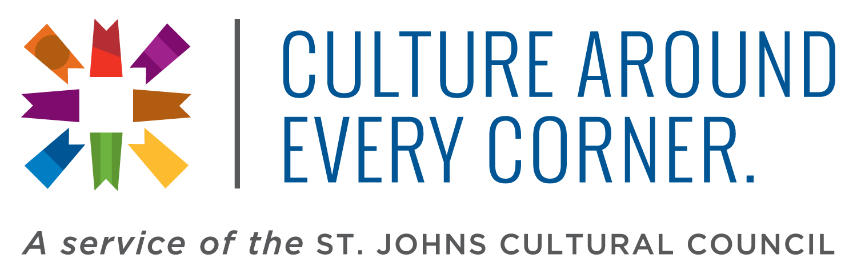
Media Contact:
Andrew Witt
awitt@historiccoastculture.com
(904) 808-7330
Literature is Preserved and Celebrated on Florida’s Historic Coast
Experience the Florida Heritage Book Festival, Poetry Readings and More

ST. AUGUSTINE, Fla. – Florida has long been a haven for authors, poets and writers, and St. Augustine’s Historic Coast is no exception. Local and statewide literary organizations work hard to promote and preserve the work of independent writers, publishers, presses and libraries in the area. Literary events, book festivals, readings, workshops and more honor the history of the written word on the Historic Coast, and you’re invited to explore it all.

The signature literary event held in the greater St. Augustine area is the Florida Heritage Book Festival and Writer’s Conference. Since 2008, the festival has annually welcomed nationally known and local authors to be honored, as well as the public to celebrate the literary arts. The festival begins with the Writers Conference. This portion is dedicated to the working writer, from the veteran to the newcomer, committed to improving his or her craft through face-to-face guidance by writing professionals.

Also in the opening days of the festival is the Literary Legend Reception, a tradition that has seen some of Florida’s most acclaimed writers honored, including Michael Connelly, Carl Hiaasen, Edna Buchanan and John Jakes. The ceremony has also recognized posthumously Marjorie Kinnan Rawlings, Zora Neale Hurston and Ernest Hemingway.

Each year The Florida Heritage Book Festival showcases Florida's rich and diverse literary legacy with author presentations and special evening events. In addition, a Festival Marketplace offers the opportunity for readers and authors to interact, prize drawings and signings.

Stretching beyond this annual festival are other literary events, including events held by the Tale Tellers of St. Augustine. The Tale Tellers was formed in 1993 by storytelling enthusiasts who are passionate about sharing historical stories about the nation’s oldest city and the people who inhabited it. Visitors can find Tale Tellers events at local libraries, festivals, historical reenactments and more. Florida Storytelling Week, which falls during the last full week in November before Thanksgiving, is held annually with storytellers holding many events at a variety of venues.

Other groups like the Ancient City Poets host workshops and poetry readings. Saint Augustine Speaks is a community open mic gathering at City Coffee Company on the last Sunday of each month. All ages and skill levels are encouraged to share a poem or just listen. The free poetry readings are held “renga style” with no emcee or sign-up sheet, so visitors are always welcome.

Any time of year arts, culture and heritage are honored on Florida’s Historic Coast. Visitors can immerse themselves in the literary arts, as well as hundreds of years of history, performing and visual arts and more.

For more information about the literary arts on Florida’s Historic Coast, visit www.historiccoastculture.com, or call (904) 808-7330. There is “Culture Around Every Corner.”
About St. Johns Cultural Council
The St. Johns Cultural Council is a 501 © (3) not-for-profit agency. Under agreement with the St. Johns County Board of County Commissioners, the SJCC provides arts, culture and heritage tourism destination marketing services to the county’s Tourist Development Council (TDC). Funding for marketing services comes from a portion of the county’s bed tax. For more information, call (904) 808-7330 or visit www.stjohnsculture.com.

###

